Project: Day 8 - Semantic Search and Embeddings Experiment
AI Provider: Google Gemini API (text-embedding-004 model)
1. What are Embeddings and Why are they Useful? (Step 9 Explanation)
An embedding is a way to convert text (like a word or a sentence) into a long list of numbers called a vector. Think of it as mapping the "meaning" of a sentence into a mathematical coordinate.
Embeddings are incredibly useful when searching through large amounts of information because they allow us to perform Semantic Search instead of just Keyword Search. If a user searches for "How much does it cost?", a traditional keyword search might fail if the document uses the words "Tuition fee is $10,000." However, an AI embedding recognizes that "cost" and "tuition fee" share a similar meaning. Their vectors will be mapped close together mathematically. This is the foundation of RAG (Retrieval-Augmented Generation), where we find the most relevant document based on a user's question, and then pass that document to an LLM to generate a final answer.
2. Source Code Repository
https://github.com/Raheemullah-Wardag/Big-Brains-
3. Practical Experiment Details
For my experiment, I created a fictional business called "TechNova Bootcamp" and wrote 10 short pieces of information about it (e.g., location, price, courses). I then converted these 10 sentences into embeddings using Google's text-embedding-004 model.
Sample Test Questions & Results:
- Question 1: "Where is the school located?"
  - Result: It successfully matched with "Our campus is located in downtown San Francisco, near the tech hub." (Similarity Score: ~0.74)
- Question 2: "How much does it cost to study here?"
  - Result: It successfully matched with "The tuition fee for the full-time program is $10,000." (Similarity Score: ~0.66)
- Question 3: "Do you help people find work after they finish?"
  - Result: It successfully matched with "We offer job placement assistance and resume reviews for all graduates." (Similarity Score: ~0.65)
Notice how the user queries didn't use the exact words (like "tuition", "San Francisco", or "placement"), but the semantic search still found the perfectly correct information based on the underlying meaning!
4. Application Screenshots
Screenshot 1: The Source Code
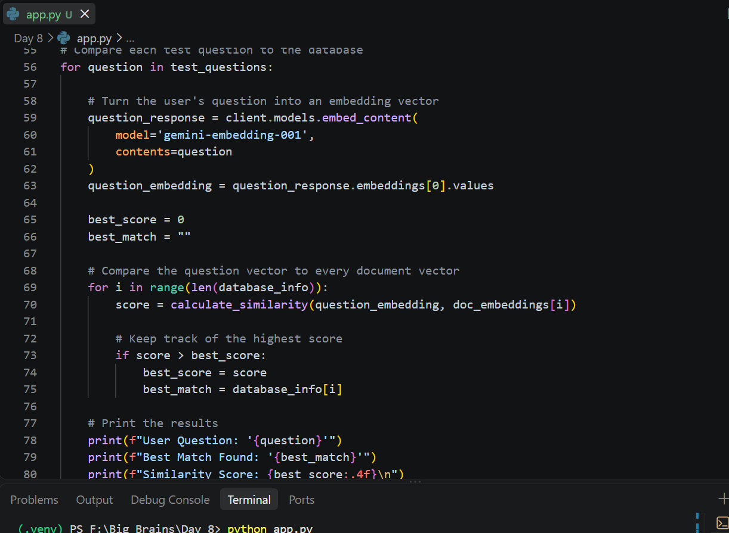
Screenshot 2: Output showing Semantic Search Matches
